

Security Risk Assessment & Treatment Methodology

Classification: Internal
This document may only be shared internally without prior confirmation from the owner.
Version | Approved By | Owner | Date Last Updated | Review Frequency | Next Review | Comments
1.0 | Dr. Noura Al-Qahtani (CEO) and the Board of Directors | Ms. Sara Al-Harbi (CISO) | September 12, 2026 | Annually, or upon material/significant changes | September 12, 2027

Contents
Purpose of This Document 1
The Risk Log 2
Roles & Responsibilities 2
Summary of approach 2
Risk Identification 3
Treatment Plans 8
Escalation 8

Purpose of This Document
The following document outlines the overall approach to information security within (Digital Horizons Bank).
It is intended as guidance on crucial aspects of managing critical principles of information security risks.
The content is for staff, auditors, suppliers and customers. Further supporting details can be found in the referenced policies and procedures.

The Risk Log
The Information security risk log can be found in Digital Horizons Bank ISMS Central Drive / Risk Management / REQUIRED-ISMS-FORM-06-1 Asset-Based Risk Tool.xlsx.
Access to the risk log is restricted to:
Access Permissions: Restricted to the Risk and Vulnerability Assessment Team, the CISO (Sara Al-Harbi) with read-only access, and designated representatives from Senior Management and Internal Audit.

Roles & Responsibilities

Information Security Group (ISG)
- Establishing the organisation's risk management policy, objectives, and risk appetite.
- Allocating necessary resources to support the risk treatment process.
- Ensuring risk treatment activities are aligned with the organisation's overall strategic objectives.
Risk owners
- Identifying and assessing risks associated with their specific areas of responsibility.
- Defining risk criteria and acceptable risk levels.
- Select appropriate risk treatment options (accept, avoid, transfer, or mitigate) based on the organisation's risk appetite and criteria.
- Implementing and monitoring risk treatment plans.
- Reporting on risk treatment progress.
Information Security Officer (ISO):
- Developing and maintaining the risk treatment methodology and associated tools and techniques.
- Providing guidance and support to risk owners and stakeholders in the risk treatment process.
- Monitoring the overall risk treatment progress and effectiveness.
- Reporting on the risk treatment process to top management and relevant stakeholders.
- Coordinating risk treatment activities.

Summary of approach
The risk management approach is broken down into five key steps:
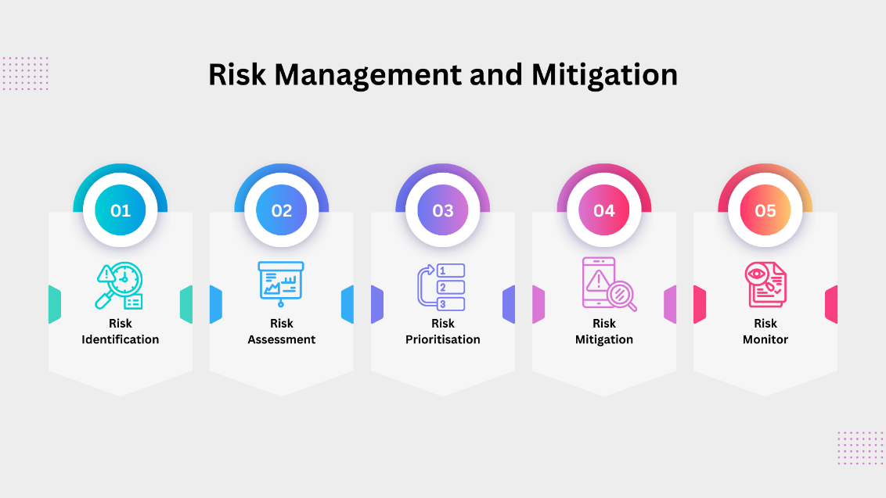

Risk Identification
The identification of security risks can come through many methods. Within the (Digital Horizons Bank), these include, but are not limited to:
- Annual review of the organisation's context – Any changes to scope, stakeholders or legislation that may introduce new risks.
- Monitoring emerging threats – through alerts from vendors on security threats, updates from the media, and notifications from organisations such as the UK National Cyber Security Centre (NCSC).
- SWOT analysis – a method of reviewing an organisation's strengths, weaknesses, Opportunities and Threats. [بنك الآفاق الرقمية (Digital Horizons Bank)] undertakes such an assessment of significant threats annually.
- Stakeholder engagement – Feedback from staff within and outside the organisation.
- Security audits – external audits, penetration & vulnerability testing. [بنك الآفاق الرقمية (Digital Horizons Bank)] uses both external audits and conducts annual penetration tests.
- Risk assessment of critical systems – A top-to-bottom review of components and the likely risks to their continued operation.

Risk Assessment
Each risk is then evaluated based on its likelihood and impact. Likelihood refers to the probability of a risk occurring, while impact represents the potential consequences if the risk materialises.
(Digital Horizons Bank) has chosen to use the following measurement scales:
Likelihood | Description | Score
Remote | - The risk is improbable to occur under normal circumstances.  - There may be no known instances or only a few rare cases in similar organisations or environments.  - This category is typically reserved for risks considered negligible or theoretical. | 1
Unlikely | - The risk has a low chance of occurring.  - It might happen in exceptional circumstances but is not expected to occur regularly.  - This level is for recognised risks uncommon in your industry or operational environment. | 2
Possible | - The risk has a moderate likelihood of occurring.  - There is an equal chance of the risk occurring or not occurring.  - It's a realistic possibility in your current environment and should be given a fair amount of attention. | 3
Probable | - The risk is more likely to occur than not.  - There have been instances of this risk materialising in similar contexts, or there are factors in your environment that increase its likelihood.  - It requires proactive management and monitoring. | 4
Highly Probable | - The risk is almost certain to occur.  - Strong evidence or historical data suggests this risk is frequent in your setting.  - This level indicates a high-priority risk that demands immediate and effective mitigation measures. | 5

Impact | Description | Score
Insignificant | - The impact is negligible, with no notable consequences on operations, reputation, or finances.  - It would not cause any interruption to normal business activities or require significant effort to address. | 1
Minor | - The impact causes a minor inconvenience that can be easily managed or resolved through routine procedures.  - It may result in a slight delay or minor costs, but it does not significantly affect business operations or objectives. | 2
Moderate | - The impact is noticeable and may cause some disruption but can be managed or worked around without significant difficulty.  - This level might involve moderate financial costs, a temporary reduction in productivity, or some strain on resources.  - It requires management attention but is within the organisation's capacity to handle effectively. | 3
Major | - The impact causes significant disruption to services or operations.  - It may result in substantial financial loss, severe damage to reputation, or considerable resource allocation to address.  - Recovery from this level of impact requires significant effort and may affect the organisation's strategic objectives or long-term plans. | 4
Catastrophic | - The impact is so severe that it threatens the existence and continued operation of the organisation.  - It could lead to long-term or permanent damage to the organisation's reputation, financial stability, or market position.  - This impact may involve legal ramifications, significant financial losses, and critical damage to organisational assets or stakeholder relationships. | 5

Risk Prioritisation
The (Digital Horizons Bank) then ranks the risks based on their likelihood and impact to help focus on the most significant ones. Using a combination of (Impact x Likelihood) gives each risk an overall rating. The top priorities are the high likelihood and high impact quadrant risks.

IMPACT | Catastrophic | 5 | 5 | 10 | 15 | 20 | 25
IMPACT | Major Disruption | 4 | 4 | 8 | 12 | 16 | 20
IMPACT | Moderate / Workaround | 3 | 3 | 6 | 9 | 12 | 15
IMPACT | Minor / Inconvenience | 2 | 2 | 4 | 6 | 8 | 10
IMPACT | Insignificant | 1 | 1 | 2 | 3 | 4 | 5
 |  |  | 1 | 2 | 3 | 4 | 5
 |  |  | Remote | Unlikely | Possible | Probable | Highly Probable
 |  |  | LIKELIHOOD

- Red: Extreme risks that threaten the continued operation of the organisation.
- Amber: Moderate risks that threaten service operations.
- Yellow: Lower risks that would cause inconvenience but could be worked around.
- Green: Insignificant risks that should be resolved but would cause no notable operational issues.

Risk Mitigation
The Information Security team will then develop strategies to manage the prioritised risks. There are four main approaches to risk mitigation:
- Accept: If a risk has a low likelihood and impact, it might be acceptable to acknowledge and monitor it.
- Avoid: If possible, change your plans to avoid the risk altogether.
- Transfer: Shift the risk to another party (e.g., through insurance or outsourcing).
- Mitigate: Implement actions to reduce the likelihood and/or impact of the risk (e.g., additional training, backup plans, diversifying suppliers).
Risk mitigation plans are then created and monitored, and ownership is assigned for resolving risks to a satisfactory level with which the [بنك الآفاق الرقمية (Digital Horizons Bank)] is comfortable.
The risk log must clearly document the selected risk treatment options (accept, avoid, transfer, mitigate).
Each decision should be justified based on the risk assessment and the organisation's risk appetite.
Documentation
Accept | Provide justification for accepting the risk, including a cost-benefit analysis if applicable.
Avoid | Describe the changes made to plans or processes to avoid the risk.
Transfer | Detail the mechanisms for transferring the risk, such as insurance or outsourcing, and the associated agreements.
Mitigate | Outline the specific actions taken to reduce the risk, including technical, administrative, and physical controls.

Risk treatment decisions should be recorded in the risk log, approved by the respective risk owner, and reviewed by the Information Security Officer (ISO).

Risk Acceptance Criteria
Risk acceptance criteria are defined as the level of risk that the organisation is willing to accept without further mitigation.
The criteria are approved by top management based on the organisation's risk appetite and strategic objectives.
Risk Appetite Statement:
"Digital Horizons Bank maintains a strictly minimal/zero-tolerance risk appetite regarding any risks that threaten the confidentiality, integrity, and availability of customer banking and personal data (in strict compliance with the Saudi Central Bank - SAMA Cybersecurity Framework and the Personal Data Protection Law - PDPL), as well as core banking systems and digital channels (Afdaq Plus / Afaq Net). The Bank maintains a low-to-moderate risk appetite exclusively within non-production and controlled sandboxed development environments, strictly ensuring no real production or customer PII is utilized."

Criteria
Low Risks (Score 1-4):** | Acceptable without further treatment, but should be monitored.
Medium Risks (Score 5-10 | May be accepted if cost of mitigation exceeds the benefits. Requires management approval.
High Risks (Score 11-15):** | Require mitigation measures to reduce risk to an acceptable level. Cannot be accepted without a comprehensive risk treatment plan.
Critical Risks (Score 16-25) | Unacceptable. Immediate action required to mitigate or transfer the risk.
These criteria are reviewed and approved by the Information Security Group (ISG) and are revisited annually or whenever significant changes occur

Risk Monitoring
Risks are continuously monitored and reviewed, with updates to the risk assessment captured as the situation evolves and the mitigation plans are adjusted accordingly.
Regular risk reviews help ensure that you stay proactive in managing risks and that your approach remains effective.

Treatment Plans
In our approach to managing and mitigating information security risks, we employ a threshold-based strategy to ensure that each risk is addressed with the appropriate level of detail and attention.
As per our combined likelihood and impact assessment, quantified risks with a score greater than ten warrant the development of a comprehensive risk treatment plan. These plans will provide in-depth strategies and actions tailored to each high-scoring risk's specific nature and complexity, ensuring robust and effective mitigation.
The mitigation strategies and control measures will be documented directly within our risk log for risks that score nine or lower. This approach allows us to maintain a concise and manageable risk log while dedicating more detailed planning and resources to risks that pose a more significant threat to our organisation's information security posture.
This methodology aligns with our commitment to a proactive and prioritised risk management process, ensuring that thorough and specific treatment plans address the most significant risks.
The Treatment Plan should be attached to the Risk Record in the Risk Log.

Escalation
Any risk deemed a 'major' category should be escalated via the management structure to the Corporate Risk Register.

